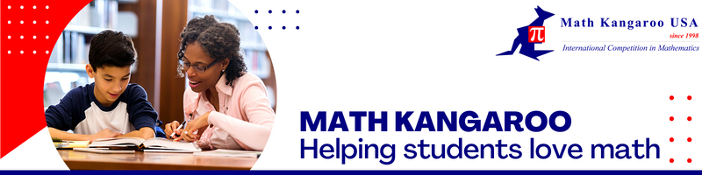
My daughter started participating in Math Kangaroo in third grade and has not missed any ever since. It stimulated her interest in math and set her on her path to pursue an education in STEM. We can't thank you has missed none ever enough for your influence on our kids.
- Math Kangaroo Parents from Texas

Dear [Insert Name]
My name is [Your Name] and I serve as a [Insert Title] for Math Kangaroo USA, a national nonprofit organization dedicated to helping students love math.
Math Kangaroo USA organizes an in-person math competition for students in grades 1-12 and we also help students prepare for the competition by practicing with creative logic and word-based problems. Throughout our 25-year history we’ve helped over 300,000 students strengthen their math skills.
After the competition is complete, Math Kangaroo recognizes the achievements of competition participants by hosting a local awards ceremony. This is an important event installing a sense of pride and accomplishment for Math Kangaroo students and they greatly appreciate the opportunity to have their hard work recognized.
As part of the ceremony we like to provide food and refreshments for the students and their families, several of which drive a significant distance for their children to participate. We would be interested in learning about opportunities for in-kind donations of food and refreshments for the Math Kangaroo ceremony and would be happy to list your company as a sponsor on any materials, on the Math Kangaroo website, and on our social media pages.
I can be reached at [your email] or by phone at [your number]. I look forward to hearing from you soon.
Best,
[Your Name]

